Bound Root

What is Bound Root
# Source: AI Source: Provided by: [Data Path: Persons Table -> ID Column: 1, Name_En Column: Motasem Essam] -> From: [Chatgpt (GPT-4-turbo)] on [7/29/2025]
A bound root is a root morpheme that cannot stand alone as a word. It must be attached to other morphemes (such as prefixes or suffixes) to form a complete word. Though it carries the core meaning of the word, it is not independently usable.

🔹 Definition of Bound Root:
# Source: AI Source: Provided by: [Data Path: Persons Table -> ID Column: 1, Name_En Column: Motasem Essam] -> From: [Chatgpt (GPT-4-turbo)] on [7/29/2025]
A bound root is a root morpheme that cannot function as a word by itself. It must be combined with one or more affixes to form a meaningful word.

🔹 Examples of Bound Roots:
# Source: AI Source: Provided by: [Data Path: Persons Table -> ID Column: 1, Name_En Column: Motasem Essam] -> From: [Chatgpt (GPT-4-turbo)] on [7/29/2025]
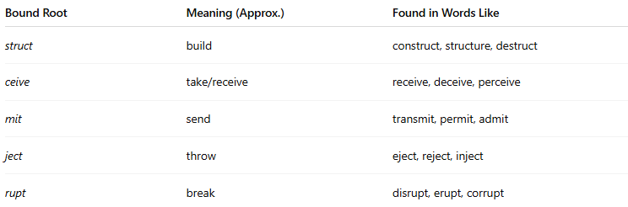
Bound Root | Meaning (Approx.) | Found in Words Like
struct | build | construct, structure, destruct
ceive | take/receive | receive, deceive, perceive
mit | send | transmit, permit, admit
ject | throw | eject, reject, inject
rupt | break | disrupt, erupt, corrupt
These roots do not occur alone in modern English but are recognizable in many words. They often come from Latin or Greek origins.

🔹 Features of Bound Roots:
# Source: AI Source: Provided by: [Data Path: Persons Table -> ID Column: 1, Name_En Column: Motasem Essam] -> From: [Chatgpt (GPT-4-turbo)] on [7/29/2025]
- ❌ Cannot stand alone as independent words.
- ✅ Always appear with affixes to form full words.
- ✅ Carry core lexical meaning of the word.
- ✅ Often of classical origin (Latin, Greek).
- ✅ Found in many derived words across English vocabulary.

🔹 Bound Root vs. Free Root:
# Source: AI Source: Provided by: [Data Path: Persons Table -> ID Column: 1, Name_En Column: Motasem Essam] -> From: [Chatgpt (GPT-4-turbo)] on [7/29/2025]
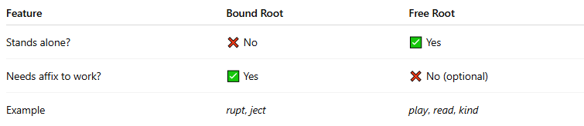
Feature | Bound Root | Free Root
Stands alone? | ❌ No | ✅ Yes
Needs affix to work? | ✅ Yes | ❌ No (optional)
Example | rupt, ject | play, read, kind

🔹 Bound Roots vs Bound Morphemes:
# Source: AI Source: Provided by: [Data Path: Persons Table -> ID Column: 1, Name_En Column: Motasem Essam] -> From: [Chatgpt (GPT-4-turbo)] on [7/29/2025]
- All bound roots are bound morphemes, but not all bound morphemes are roots.
- For example, -ed, -s, un- are bound affixes, but not roots.

